RED RIBBON WEEK  at the RIDGE!  OCTOBER 26-30  SPONSORED BY: PRHS C.O.R.E. CLUB  Joining forces with other clubs on campus to show tHERE’s MUCH MORE FOR PRHS STUDENTS TO DO THAN DRUGS!  LUNCH TIME EVENTS TO INCLUDE:  MONDAY: DRUGS ARE CORNY … CORNHOLE CONTEST WITH CORNHOLE SETS MADE BY CONSTRUCTION ACADEMY & POPCORN BY S.G.A.  TUESDAY: STOMP OUT DRUGS … BALLOON STOMP WITH GIRLS’ VOLLEYBALL AND SWIM TEAM  WEDNESDAY: CHALK IT UP TO GOOD CHOICES SIDEWALK ART WITH PROJET UNIFY  THURSDAY: JOIN THE FIGHT AGAINST DRUGS … JROTC PIE EATING CONTEST & M.A.D.D. PHOTO BOOTH  FRIDAY: TUNE OUT DRUGS PERFORMANCE BY PRHS DRUM LINE & M.A.D.D. PHOTO BOOTH |  |  | MON. 10/26  REspect the red! wear red day  Tues. 10/27  TEAM UP AGAINST DRUGS!  FAVORITE SPORTS TEAM  WED. 10/28  LEI OFF DRUGS  HAWAIIN ATTIRE DAY  THURS. 10/29  JOIN THE FIGHT AGAINST DRUGS!  CAMO DAY  FRI. 10/30  PRHS STRIVES TO BE DRUG-FREE!  SCHOOL SPIRIT DAY  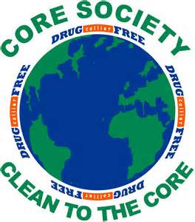  It’s never a bore  with PRHS C.O.R.E.!

