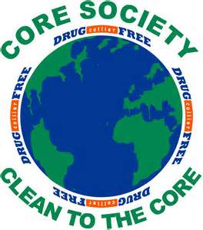
`
CORE Society Pledge Palmetto Ridge High School
C-Character O-Opposing Drugs R-Responsible Choices E-Expectations
The following information will be provided to your CORE advisor and Drug Free Collier.
I pledge to:
1. Live a drug-free life;
2. Show my friends and family that a drug-free life is more fun;
3. Learn more about the harmful effects of drugs and alcohol;
4. Share the truth about the harmful effects of drugs and alcohol;
5. Encourage my family and friends to be drug-free and healthy.

Student Signature: ______________________________ Date: ______________

Student Information
Print Name____________________________________ Grade ___________________

Email: __________________________________

Congratulations!
You signed the pledge, and …
you are a part of PRHS C.O.R.E. Society,
a club dedicated to remaining drug-free
and making smart, healthy choices.

In celebration of Red Ribbon Week (Oct. 23-31), enjoy some good, clean fun!
Coral Cay Adventure Golf has agreed to give our C.O.R.E. students a discounted rate.
Coral Cay Adventure Golf
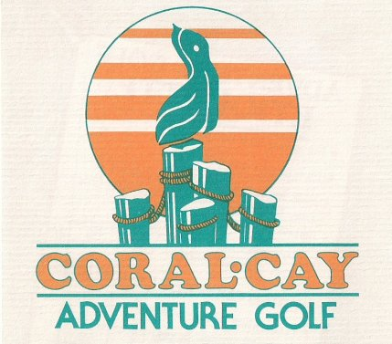
2205 E. Tamiami Trail • Naples
1 Mile East of Tin City
239-793-4999
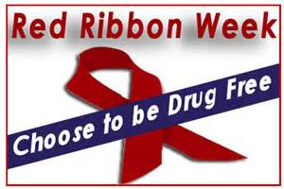
Any student who wears red or their CORE T-shirt during Red Ribbon Week can play 18 holes of miniature golf
for just $4.50.

Remember to bring this flyer or mention Red Ribbon Week
in order to receive the discount.
Happy Golfing!

