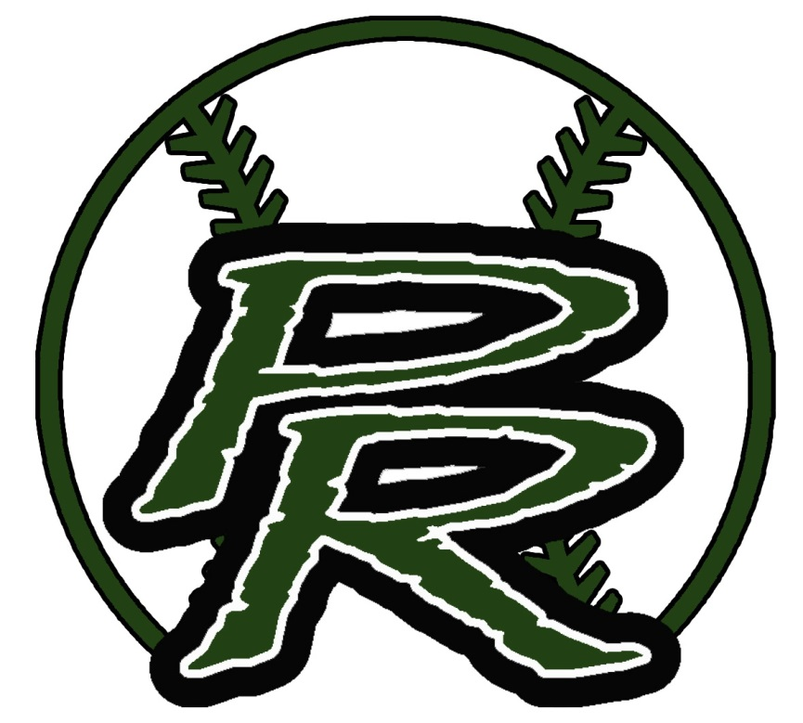

**Palmetto Ridge strikes out drugs!**



**Palmetto Ridge**

**sets up**

**a bright future without drugs!**

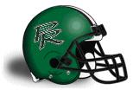

**Palmetto Ridge**

**tackles drugs and changes lives.**





**Palmetto Ridge’s**

**goal is**

**to be drug-free!**



**PRHS**

**shoots**

**for a**

**drug-free**

**lifestyle.**



**PRHS thinks drugs are**

**un-bear-able!**

PRHS

serves up

a drug free

lifestyle!





PRHS

cheers on

those who

agree to be

drug free!



[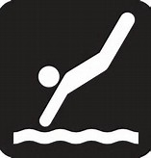](http://www.bing.com/images/search?q=Swimming+and+Diving+Clip+Art&FORM=RESTAB#view=detail&id=5299A5F2837CA09A98D76D29B4909F1C6C2224EF&selectedIndex=20)

PRHS

dives

into a

drug-free

lifestyle!



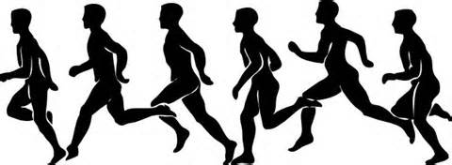

Drugs?

PRHS

runs the other direction because we agree to be

drug free!



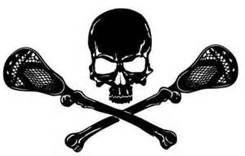

PRHS

picks

a drug-free

lifestyle!

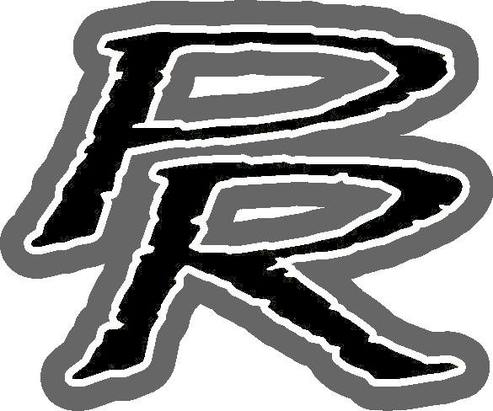

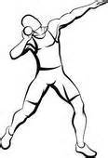

PRHS students

put

their future first;

we agree to be

drug free!

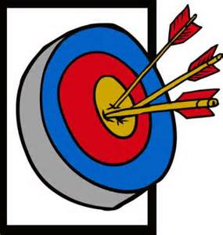

PRHS students’ futures

are on target

because we agree to be drug-free!



[](http://www.bing.com/images/search?q=rugby%20clip%20art&qs=n&form=QBIRMH&pq=rugby%20clip%20art&sc=3-13&sp=-1&sk=#view=detail&id=3A0718F1346063A8BEC10B7C34AB5CD6D358D2C4&selectedIndex=38)

PRHS students

always try

to live

above the influence.

[](http://www.bing.com/images/search?q=camera%20clip%20art%20with%20negative&qs=n&form=QBIR&pq=camera%20clip%20art%20with%20negative&sc=0-16&sp=-1&sk=#view=detail&id=8B9F6BB74F858BD39F252C07318AAE39FB27219F&selectedIndex=22)

PRHS students limit the negative exposure they have to drugs; they agree to just say no!





PRHS’s

cadence is we agree to be

drug free!



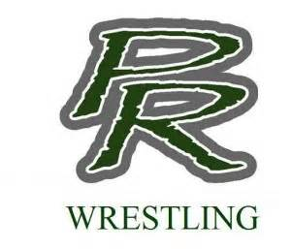

PRHS

takes down

drugs.

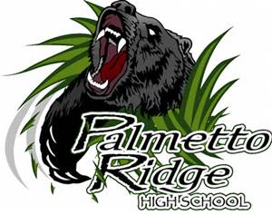

PRHS

brushes off drugs!



PRHS knows the key to a good life is staying

drug free.

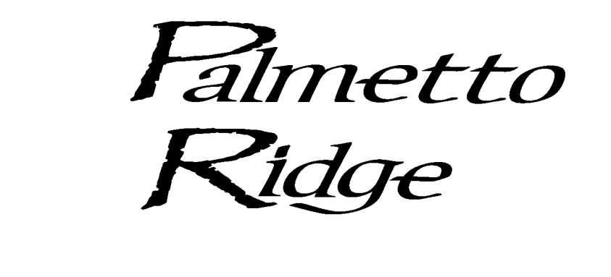

**We stay on the right track …**

**we run away from drugs!**

